Game Design Document

# Team Members

Nate – Tech Lead

Eric – Game Design Lead

Tessa – Art and Sound Lead

Evan – Game director

Zach - Producer

# Game Overview

## High Concept (Elevator Pitch)

An underwater themed 2D shooter, where the enemies you face get progressively harder as you dive deeper into the ocean. Survive for as long as you can as you are aided by unique powerups from each enemy you defeat, which vary depending on their real-life biological features.

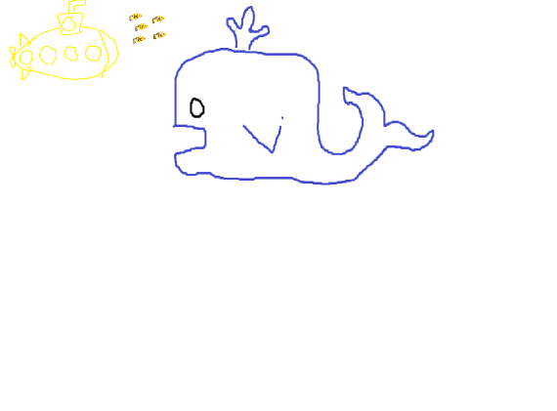

## Game Summary

Captain a submarine and dive into the endless depths of the ocean. Various marine creatures will spawn, having a unique ability that can be obtained by defeating that creature. As you adventure deeper into the ocean, it will get progressively more difficult, so make sure to take advantage of all your extra abilities and defeat everything in your path.



# Gameplay

## First Minutes

The player starts on the surface of the water off the coast of a tropical island. Vicious fish and sharks surround the player. The player uses WASD to move and space to shoot.

## Game Flow

The player starts at the surface and after they defeat different waves of enemies, the player goes through an opening to the next level. Levels are endless and enemies get progressively more difficult as waves progress.

## Victory/Lose Conditions

Lose – player loses health and dies.

Victory – high score point saving.

# Target Audience

Casual gamers, 6+.